What mechanisms link activated carbon to water treatment
在现代水处理技术体系中，活性炭滤料作为一种多功能材料，通过物理吸附、化学作用与催化反应的协同效应，构建起污染物去除的核心屏障。这种联系首先体现在活性炭滤料独特的多孔结构所主导的物理吸附过程中——其内部发达的微孔、中孔与大孔网络形成的巨大比表面积，如同千万个微型陷阱，通过范德华力将水中的有机物、嗅味物质及部分重金属离子牢牢捕获。在饮用水处理中，活性炭滤料的物理吸附作用尤为关键，它能高效去除腐殖酸、农药残留等天然有机物，同时降低消毒副产物前体物浓度，这也是为何在水厂深度处理工艺中，活性炭滤料过滤单元往往作为保障水质安全的最后一道防线。
活性炭滤料与水处理的第二层机制联系建立在表面化学修饰的基础上。经过特殊处理的活性炭滤料表面会形成羧基、羟基等含氧官能团，这些活性位点能与水中污染物发生化学键合，实现从物理吸附到化学吸附的转变。例如在工业废水处理中，负载氨基官能团的活性炭滤料可选择性吸附重金属离子，通过离子交换与络合反应将Pb²⁺、Cr⁶⁺等有毒物质固定在滤料表面；而在市政污水处理中，表面改性的活性炭滤料能有效去除水中的磷酸盐，通过化学沉淀作用助力水体富营养化控制。这种化学作用机制使活性炭滤料突破了物理吸附的局限性，具备了针对特定污染物的靶向去除能力。
更深层次的机制联系则体现在活性炭滤料的催化特性上。作为一种优良的催化剂载体，活性炭滤料不仅能吸附污染物，更能通过表面活性位点促进化学反应的进行。在高级氧化工艺中，活性炭滤料负载的纳米铁颗粒可催化过氧化氢分解产生羟基自由基，将难降解有机物氧化为无害的二氧化碳和水；而在饮用水深度处理中，活性炭滤料能加速臭氧分解，提高氧化效率的同时减少溴酸盐生成风险。值得注意的是，当活性炭滤料应用于生物活性炭工艺时，其多孔结构还能为微生物提供栖息场所，形成"吸附-生物降解"的协同体系，使污染物在被吸附富集后进一步被微生物分解，这种动态平衡显著延长了活性炭滤料的使用寿命。
从市政供水到工业废水处理，从应急水质净化到长期运行的水处理系统，活性炭滤料始终扮演着关键角色。它通过多层次的作用机制，将物理截留、化学转化与生物降解有机融合，成为水处理技术中不可或缺的功能材料。随着材料改性技术的发展，未来的活性炭滤料将在选择性、催化效率和再生性能上实现更大突破，持续深化与水处理技术的机制联系，为水环境保护提供更坚实的技术支撑。

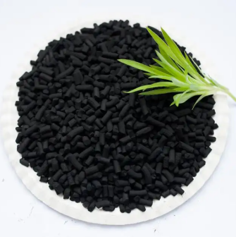
What mechanisms link activated carbon to water treatment
In the modern water treatment technology system, activated carbon filter media builds the core barrier for pollutant removal through the synergistic effect of physical adsorption, chemical reactions, and catalytic reactions. This connection is first manifested in the physical adsorption process dominated by the unique porous structure of activated carbon filter material - the internal well-developed micro-pore, meso-pore, and macro-pore network forms a huge specific surface area, like millions of micro-traps, capturing organic matter, odor substances, and some heavy metal ions in water through van der Waals forces. In drinking water treatment, the physical adsorption effect of activated carbon filter material is particularly crucial, as it can efficiently remove natural organic matter such as humic acid and pesticide residues, while reducing the concentration of disinfection by-product precursors. This is why in the advanced treatment process of water plants, the activated carbon filter material filtration unit often serves as the last line of defense for ensuring water quality safety.
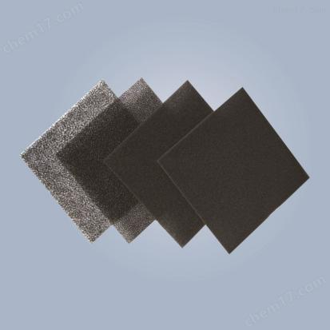
The second layer of mechanism connection between activated carbon filter material and water treatment is based on surface chemical modification. After special treatment, the surface of activated carbon filter material forms oxygen-containing functional groups such as carboxyl and hydroxyl groups. These active sites can chemically bond with pollutants in water, achieving a transformation from physical adsorption to chemical adsorption. For example, in industrial wastewater treatment, activated carbon filter material loaded with amino functional groups can selectively adsorb heavy metal ions, fixing toxic substances such as Pb²⁺ and Cr⁶⁺ on the surface of the filter material through ion exchange and complexation reactions; while in municipal wastewater treatment, surface-modified activated carbon filter material can effectively remove phosphates from water, assisting in the control of water eutrophication through chemical precipitation. This chemical action mechanism enables activated carbon filter material to break through the limitations of physical adsorption and possess targeted removal capabilities for specific pollutants.
The deeper mechanism connection lies in the catalytic properties of activated carbon filter material. As an excellent catalyst carrier, activated carbon filter material can not only adsorb pollutants but also promote chemical reactions through surface active sites. In advanced oxidation processes, nano-iron particles loaded on activated carbon filter material can catalyze the decomposition of hydrogen peroxide to produce hydroxyl radicals, oxidizing refractory organic matter into harmless carbon dioxide and water; while in advanced drinking water treatment, activated carbon filter material can accelerate the decomposition of ozone, improving oxidation efficiency while reducing the risk of bromate formation. Notably, when activated carbon filter material is applied in the biological activated carbon process, its porous structure can provide a habitat for microorganisms, forming a "adsorption-biodegradation" synergy system, where pollutants are further decomposed by microorganisms after being adsorbed and concentrated. This dynamic balance significantly extends the service life of activated carbon filter material.
From municipal water supply to industrial wastewater treatment, from emergency water purification to long-term operating water treatment systems, activated carbon filter material always plays a key role. Through multi-level action mechanisms, it organically integrates physical interception, chemical transformation, and biological degradation, becoming an indispensable functional material in water treatment technology. With the development of material modification technology, future activated carbon filter materials will achieve greater breakthroughs in selectivity, catalytic efficiency, and regeneration performance, continuously deepening the mechanism connection with water treatment technology and providing more solid technical support for water environmental protection.

