What is honeycomb activated carbon used for
蜂窝活性炭作为一种具有高度发达孔隙结构的功能性碳材料，凭借其比表面积大、通孔阻力小、吸附容量高的特性，已从工业环保领域逐步渗透到日常生活的方方面面，成为现代污染治理与品质提升的关键材料。在工业废气处理中，它犹如一位沉默的净化卫士，广泛应用于化工、印刷、涂装等行业的废气治理工程，通过吸附法有效捕捉挥发性有机物、恶臭气体及工业粉尘，其独特的蜂窝结构设计使废气通过时阻力降低30%以上，配合活性炭箱等设备可实现污染物去除率达90%以上，助力企业实现废气达标排放。在水处理领域，蜂窝活性炭则化身为精密的过滤能手，无论是饮用水深度净化中去除余氯、有机物，还是工业废水中吸附重金属离子与染料色素，其微孔结构都能像分子筛般精准截留污染物，某水质净化厂数据显示，使用蜂窝活性炭后水中TOC（总有机碳）含量可降低至0.5mg/L以下，远优于国家标准。
走进日常生活场景，蜂窝活性炭的应用更显贴心实用。新装修的房屋内，它能主动吸附甲醛、苯系物等装修污染物，实验表明100平方米空间配置5公斤蜂窝活性炭，可使室内甲醛浓度在72小时内从0.3mg/m³降至安全值以下；厨房、卫生间等异味重灾区，通过内置蜂窝活性炭的除味盒，能快速中和硫化氢、氨气等臭味分子，保持空气清新。在特殊场景中，其功能进一步延伸——保藏书画古籍时，它能调节微环境湿度至50%-60%的最佳区间，同时吸附霉菌孢子，使珍贵文献得以长久保存；鱼缸水质净化中，它既能吸附鱼便分解产生的亚硝酸盐，又不会破坏水体生态平衡，是水族爱好者的理想选择。
随着环保要求的升级与材料技术的进步，蜂窝活性炭的应用边界仍在不断拓展。在新兴的储能领域，经过特殊改性的蜂窝活性炭可作为超级电容器的电极材料，其优异的导电性与离子吸附能力有望提升储能设备的充放电效率；农业领域的探索研究显示，将蜂窝活性炭按1:500比例混入土壤，能吸附残留农药与重金属，同时改善土壤透气性，促进作物根系生长。这种源自传统炭材料的现代产物，正以其多功能性与环境友好特性，在工业生产与日常生活中构建起一张隐形的净化网络，为可持续发展与品质生活提供着默默支撑。

What is honeycomb activated carbon used for
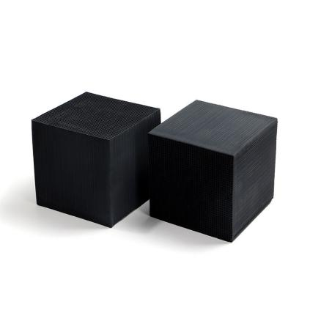
As a functional carbon material with a highly developed porous structure, honeycomb activated carbon has gradually permeated all aspects of daily life from the industrial environmental protection field, thanks to its large specific surface area, small through-hole resistance, and high adsorption capacity. It has become a key material for modern pollution control and quality improvement. In industrial exhaust gas treatment, it acts like a silent purification guardian, widely used in exhaust gas treatment projects of industries such as chemical engineering, printing, and coating. Through adsorption methods, it effectively captures volatile organic compounds, malodorous gases, and industrial dust. Its unique honeycomb structure design reduces exhaust gas resistance by more than 30% when the gas passes through, and combined with equipment such as activated carbon boxes, it can achieve pollutant removal rates of over 90%, helping enterprises achieve compliant exhaust gas emissions. In the water treatment field, honeycomb activated carbon transforms into a precision filtration expert. Whether it is removing residual chlorine and organic matter in deep drinking water purification or adsorbing heavy metal ions and dye pigments in industrial wastewater, its microporous structure can precisely intercept pollutants like a molecular sieve. Data from a water purification plant shows that after using honeycomb activated carbon, the TOC (Total Organic Carbon) content in water can be reduced to below 0.5 mg/L, far exceeding the national standard.
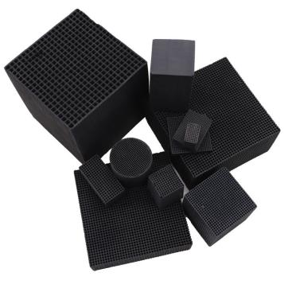
In daily life scenarios, the application of honeycomb activated carbon is even more practical. In newly decorated houses, it actively adsorbs pollutants such as formaldehyde and benzene series compounds. Experimental results show that configuring 5 kg of honeycomb activated carbon in a 100 square meter space can reduce the indoor formaldehyde concentration from 0.3 mg/m³ to a safe level within 72 hours. In odor-prone areas such as kitchens and bathrooms, odor-removing boxes with built-in honeycomb activated carbon can quickly neutralize odor molecules such as hydrogen sulfide and ammonia, keeping the air fresh. In special scenarios, its functions are further extended – when preserving calligraphy, paintings, and ancient books, it can adjust the micro-environment humidity to the optimal range of 50%-60% and adsorb mold spores, allowing precious documents to be preserved for a long time. In fish tank water quality purification, it can adsorb nitrites produced by the decomposition of fish feces without disrupting the aquatic ecosystem balance, making it an ideal choice for aquarists.
With the upgrading of environmental protection requirements and the progress of material technology, the application boundaries of honeycomb activated carbon continue to expand. In the emerging energy storage field, specially modified honeycomb activated carbon can be used as electrode material for supercapacitors, and its excellent conductivity and ion adsorption capacity are expected to improve the charging and discharging efficiency of energy storage devices. Research in the agricultural field shows that mixing honeycomb activated carbon into soil at a ratio of 1:500 can adsorb residual pesticides and heavy metals while improving soil aeration and promoting crop root growth. This modern product derived from traditional carbon materials is building an invisible purification network in industrial production and daily life with its multifunctionality and environmental friendliness, providing silent support for sustainable development and quality life.

